INTRODUCTION
This document has been prepared as guidance for the structural-geotechnical collaboration in the successful preparation of a Seismic Risk Assessment (SRA) report.
This document focuses on the following collaborative contributors to the preparation of a SRA:
(1) Structural engineer-of-record (EOR);
(2) TRB structural engineering reviewer (structural reviewer);
(3) TRB geotechnical engineering reviewer (geotechnical reviewer).
Many SRAs are strongly influenced by the geotechnical assumptions and engineering judgements regarding soil amplification and liquefaction potential of school sites. The quantity and quality of the geotechnical information that is available at the SRA stage varies from site to site but is typically limited relative to the data that is required to assess site amplification and liquefaction potential. The lack of information on ground conditions to a depth of at least 30 m, which is required to determine an applicable V_{s30} value, results in a high degree of uncertainty on this critical input parameter that is required for calculation of the Probability of Drift Exceedance (PDE) using the SRG Analyzer.
The current approach of assigning a retrofit priority ranking (RPR) based on the PDE calculated using a single V_{s30} value does not consider the degree of V_{s30} uncertainty at each site. When a V_{s} profile to a depth of 30 m is not available at a site, the PDE calculations should consider an appropriate range of potential V_{s30} values, with a range that reflects the degree of uncertainty of ground characteristics. However, a wide range of V_{s30} values may result in different RPRs and such an approach should be avoided, as it would not provide guidance on which RPR should be assigned to a given school block.
This document outlines a proposed sequence for the efficient and effective structural-geotechnical collaboration for carrying out an SRA for a school site considering incomplete or unknown V_{s} information (uncertainty). The recommended approach for incorporating V_{s30} uncertainty in the SRG Analyzer for the purposes of conducting an SRA depends on the available subsurface information. The following classification system is proposed to guide the structural-geotechnical collaboration process and for assigning an appropriate budget allowance for the geotechnical review:
- Scenario I: A site-specific geotechnical report is provided to the geotechnical reviewer that contains adequate subsurface data to define a single site class (e.g. using depth-limited V_{s} data and/or N₆₀ values) and liquefaction has been properly addressed.
- Scenario II: A site-specific geotechnical report is available but without adequate investigation to confidently define a single site class or to assess liquefaction potential (e.g. only test pits or shallow test holes in Site Class D or E ground conditions); or a site-specific geotechnical report is not available. In these cases, both V_{s30} and liquefaction potential are highly uncertain and must be inferred from surficial geology mapping, nearby water well records and/or site topography, which is information that the geotechnical reviewer would typically need to search and compile.

Any geotechnical reports for a school site should be provided to the geotechnical reviewer during the SRA initiation phase, the geotechnical reviewer reviews the available geotechnical report and confirms whether or not the information in the report is adequate for assigning an appropriate site class and for assessing the potential for liquefiable soils. The approach that the EOR and the geotechnical reviewer take to establish the most likely RPR depends on which of the site scenarios is considered to be applicable based on the available geotechnical information for the site, as follows:
- Scenario I: Once the geotechnical reviewer confirms the site class designation, the EOR can use the range of V_{s30} values corresponding to the designated site class to compute a range of PDE values corresponding to that site class. If the range of PDE values results in different RPR categories, the EOR should determine the V_{s30} value(s) corresponding to the RPR boundary or boundaries within the V_{s30} range defined by the designated site class, as described below.
- Scenario II (and in Scenario I when the V_{s30} range corresponding to the designated site class results in different RPRs): The EOR first uses the SRG Analyzer to identify the site-specific relationship between V_{s30} and PDE for each applicable structural prototype. The EOR uses that relationship to determine the V_{s30} values that correspond to the PDE thresholds that define each RPR (i.e. PDE = 2%, 5%, 7% and 10%) and then provides the corresponding V_{s30} range for each RPR to the geotechnical reviewer. The geotechnical reviewer then assigns likelihood ratings to each RPR and/or selects the most likely priority ranking based on the range of V_{s30} that can be expected at a site based on the available geotechnical/geological information. An example of the proposed approach is provided in the last section of this document.
The proposed approach assumes that V_{s30} is an adequate predictor of site amplification behaviour for the purpose of conducting the SRA. This may not be the case for sites having a strong impedance contrast where resonant amplification may be focused at the fundamental period of the site. A comment on V_{s30} applicability should be included in the geotechnical review documentation.

SRA COLLABORATIVE PROCEDURE
Refer to Table 1 for a summary of the proposed collaborative contributions of the EOR, the structural reviewer and the geotechnical reviewer in the successful completion of a SRA.

Table 1: Structural-Geotechnical Collaborative Procedure for SRA Completion
No. | SRA Phase | Collaborative Procedure Details
1 | SRA Initiation | (a) TRB Manager initiates SRA.  (b) TRB Manager informs EOR, structural reviewer and geotechnical reviewer of SRA start-up.  (c) All available background information, including school block locations and geotechnical reports relevant to the site conditions, are provided to the geotechnical reviewer at the onset.  (d) Geotechnical reviewer reviews background information and assigns site scenario classification based on available geotechnical/geological information (as described above).  (e) EOR, structural reviewer and geotechnical reviewer have virtual meeting to discuss SRA approach, as well as project timelines and expectations.
2 | Geotechnical Site Characterization | - Geotechnical reviewer compiles available geotechnical data for the site and supplements with available surficial geology and bedrock geology mapping and nearby water well records if necessary.  - Geotechnical reviewer confirms V_{s30} or applicable seismic site class(es) (depending on available subsurface data) and sends written confirmation (e-mail) of the range of V_{s30} to the EOR.
3 | RPR-V_{s30} Sensitivity Assessment | - For each applicable structural prototype, EOR uses the SRG Analyzer to calculate the range of PDE for the range of V_{s30} assigned by the geotechnical reviewer, and sends the results to the geotechnical reviewer.  - If the computed range of PDE results in multiple RPR categories, the EOR can assign the most conservative RPR; or  - The EOR uses the SRG Analyzer to determine the site-specific relation between PDE and V_{s30} and sends the prototype-specific V_{s30} range for each RPR category to the geotechnical reviewer (see example below); and  - The geotechnical reviewer completes an assessment of RPR likelihood based on the EOR-supplied V_{s30} ranges for each RPR.
4 | EOR / Geotechnical Collaboration | - Geotechnical reviewer sends written confirmation (e-mail) of the assessed likelihood of RPRs and liquefiable site conditions to EOR, structural reviewer and TRB Manager.  - EOR and geotechnical reviewer may have virtual meeting to discuss:  i) adequacy of available geotechnical information;  ii) sensitivity of the SRA to V_{s30} assumptions;  iii) assessment of the likelihood of RPRs and liquefiable site conditions based on available information; and  iv) the potential benefits of additional geotechnical investigation.
6 | SRA Preparation and Completion | (a) EOR prepares first draft of the SRA including the range of computed PDE for the V_{s30} range recommended by the geotechnical reviewer, and recommendation of most likely RPR(s) if applicable.  (b) Structural reviewer and geotechnical reviewer complete their reviews of the EOR’s first draft of the SRA.  (c) EOR completes the SRA with structural and geotechnical reviewer signoffs.

GEOTECHNICAL REVIEWER BUDGET ALLOWANCE
The budget allowance that should be allocated for geotechnical review of SRAs using a desktop study approach following the procedure described in Table 1 depends on the level of subsurface information provided to the geotechnical reviewer, as defined in the site scenario classifications described above. The following levels of effort should be assumed:
- Scenario I: 4.0 hours, or
- Scenario II: 8.0 hours

The above budgets do not include allowance for considering site period-dependent amplification within the SRA.

EXAMPLE (Site Scenario II)
The proposed approach of assigning RPR likelihood using the site and prototype-specific relationship between V_{s30} and PDE is illustrated using an example of a site on Flores Island (N of Tofino) which was lacking a geotechnical report and without geological mapping or water well records, resulting in a high degree of uncertainty on V_{s30}. The SRA was based on assumed Site Class C, for which V_{s30} = 360 m/s was conservatively assumed, resulting in an H2 retrofit priority ranking.
Based only on outcropping rock that is visible along the shoreline in the aerial photo and the surface elevations from Google Earth, a very wide range of V_{s30} values would be calculated using a range of V_{s-soil} and V_{s-rock} scenarios and considering multiple bedrock depths in the range of 1 m to 15 m. In this example, a lognormal probability density function (PDF) was assigned to a data set of V_{s30} estimates (see the pink curve on the figure below) to illustrate the relative likelihood of different V_{s30} values.
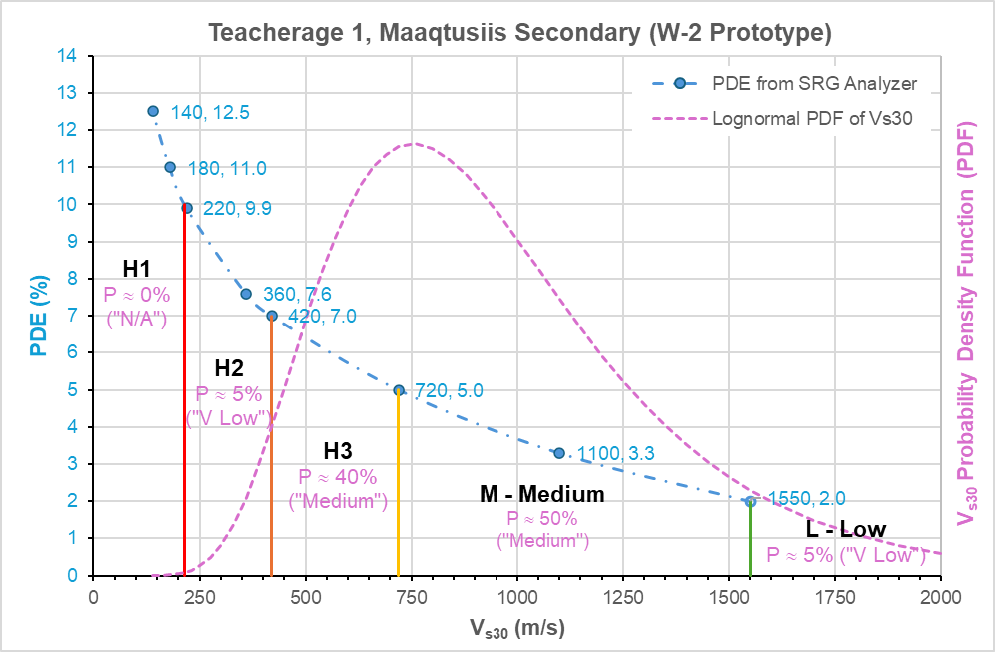
The cumulative density function (CDF) corresponding to the PDF shown was used to calculate probabilities associated with the PDE-based V_{s30} ranges. The estimated probabilities suggest that the likelihood of an H2 ranking being applicable is actually very low, whereas there is about a 50% probability that a Medium RPR is the most appropriate. When considering whether an SPIR should be carried out for this block, there is a slightly lower likelihood that a “High” priority is warranted (45% probability) than a M to L priority (55% probability). In this case, the EOR could choose to assign a Medium RPR, or could be more conservative and assign a range of RPRs from M to H3 to indicate to the Ministry that there is a relatively high degree of uncertainty due to lack of information on subsurface conditions at this site. The EOR should consider the risk of RPR uncertainty on the structural performance and use engineering judgement in the choice of RPR to assign.
The proposed approach enables a judgement-based decision to be made on selecting the most appropriate RPR (or range of RPRs) to assign, without implying a degree of V_{s30} certainty that does not exist, while also avoiding over-conservatism. This is a good example of a site where additional geotechnical information would allow the V_{s30} uncertainty to be reduced and the RPR confidence to be improved.
CLOSURE
This document represents the initial version of a proposed approach to structural-geotechnical collaboration in Seismic Risk Assessment (SRA). It is expected to evolve as more school sites are evaluated and as practical experience is gained. Continuous improvement will rely on close coordination between geotechnical and structural engineers, particularly in refining procedures for handling V_{s30} uncertainty and retrofit priority ranking (RPR) assignments. Constructive feedback and shared insights from all contributors are strongly encouraged to enhance the clarity, applicability, and effectiveness of future versions.

