Seismic Project Identification Report

SPIR GUIDELINES
Edition 3.1

Structural Engineering Guidelines for the
Performance-Based Seismic Assessment and Retrofit of
Low-Rise British Columbia School Blocks

PREFACE
The Seismic Project Identification Report (SPIR) is a specific report format that documents the seismic risk and the retrofit concepts proposed for a seismically deficient school block.
The Ministry of Education (Ministry) requires that School Districts provide an SPIR for any school block that is identified as having high seismic risk.
Please note that SPIRs should not be initiated without the prior approval from the Ministry.
Engineers & Geoscientists BC, as the Ministry's technical advisor for the Seismic Mitigation Program, was requested by the Ministry to develop the format and technical requirements for the SPIR. This manual provides the necessary guidance for a consultant to prepare a SPIR on behalf of a School District.
SPIRs are due-diligence documents that are designed to confirm the seismic risk and present seismic upgrading options to assist seismic safety planning by both School Districts and the Ministry. The expectation is that SPIR information will guide the seismic upgrading of a school block in a consistent, safe, and cost-effective manner.
From a structural engineering perspective, the SPIR leads into the preparation of the PDR through the list of PDR requirements given in Chapter 11 of the SPIR.
Ongoing feedback from engineering practitioners is encouraged to advance future refinements of the SPIR document.

GUIDELINES UPDATES
SPIR Guidelines Edition 3.1 were approved by the Technical Review Board on August 25, 2025. The revised guidelines include the following significant revisions made to the previous version (SPIR Guidelines Edition 3.0 in July 2018):
- Phased option has been removed.
- Amended SPIR consulting fee schedule (Appendix D).
- Revised SRG references to SRG 2023 (released in January 2025).
- Addition of Probable Seismic Event Ranking.
The SPIR version in use at present was updated and released in August 2023. It is expected an updated version of the SPIR will be developed over the coming year and will be issued as an online form.

ACRONYM DEFINITIONS
The following acronyms have been used in this document:
SPRFS is the Seismic Project Request Fact Sheet that a School District submits to the Ministry to document the School District's application for project support. The SPRFS details the project rationale and project scale as presented in the School District Facilities Plan. SPRFSs are supported by Seismic Project Assessments (SRAs), an online form that is used to confirm seismic risk to blocks.
PDR is the Project Definition Report that a School District submits to the Ministry as a precursor for a Capital Project Funding Agreement for a supported project. The PDR details all aspects of the supported project so that the project can proceed to Project Design and Development after the Capital Project Funding Agreement is finalized.
TRB is the Technical Review Board that is administered by Engineers and Geoscientists British Columbia (the Association) on behalf of the Ministry. The TRB is composed of structural engineers, geotechnical engineers, and construction cost consultants who have extensive experience in seismic engineering projects. All SPIRs and PDRs are to be reviewed by the TRB before acceptance by the Ministry.

Table of Contents
CHAPTER | Section Title | Page
PREFACE i
GUIDELINES UPDATES ii
ACRONYM DEFINITIONS iii
Table of Contents iv
1.0 GENERAL REQUIREMENTS 1-1
1.1 Introduction 1-1
1.2 Mandatory Submission 1-1
1.3 SPIR Funding 1-1
1.4 SPIR Contract Award 1-1
1.5 Objective 1-1
1.6 Initiating a SPIR 1-1
1.7 Retrofit Concepts 1-2
1.8 SPIR Summary Page 1-2
1.9 Technical Reference 1-2
1.10 Schedule 1-2
1.11 Risks 1-2
1.12 Prime Consultant Qualifications 1-2
1.13 Construction Cost Consultant 1-2
1.14 Construction Cost TRB Review 1-2
1.15 Construction Cost Consultant Qualifications 1-3
1.16 Architectural, Mechanical, and Electrical Engineering Services 1-3
1.17 Geotechnical Investigations 1-3
1.18 Field Testing 1-3
1.19 Relevant Reference Documents 1-4
1.20 Coordination of Multi-disciplinary Team 1-4
1.21 OFCs (Non-structural Hazards) 1-4
1.22 Probable Seismic Event Ranking 1-4
1.23 Next Steps 1-5
2.0 TECHNICAL REVIEW BOARD 2-1
3.0 TRB PDR REQUIREMENTS 3-1
3.1 Introduction 3-1
3.2 TRB Review Panel Lead 3-1
3.3 Continuity of Retrofit Concept 3-1
3.4 Scope of TRB Review Meetings 3-1
3.5 Changes to SPIR 3-1
3.6 Operational and Functional Components (OFCs) 3-1
3.7 Administration 3-1
3.8 Ministry-directed Specialized TRB Review 3-1
3.9 Due Diligence 3-2
3.10 Sign-off 3-2
3.11 Lessons Learned 3-2
4.0 ARCHITECTURAL, MECHANICAL, AND ELECTRICAL ENGINEERING GUIDELINES 4-1
4.1 Background 4-1
4.2 British Columbia Building Code (BCBC) 4-1
4.3 Vancouver Building Bylaw (VBBL) 4-1
4.4 Professional Practice Standards 4-2
4.5 Structural Engineering Post-SPIR 4-2
4.6 Architectural Building Systems 4-2
4.7 Mechanical and Electrical Building Systems 4-3
4.8 Conclusion 4-3
APPENDIX A: DEFINITIONS A-1
APPENDIX B: SPIR BLANK TEMPLATE B-1
APPENDIX C: SPIR BLANK TEMPLATE COMMENTARY C-1
APPENDIX D: SPIR CONSULTING FEE SCHEDULE D-1
APPENDIX E: CLASS C CONSTRUCTION COST ESTIMATE E-1
APPENDIX F: SCOPE OF REVIEW OF CONSTRUCTION COST ESTIMATE F-1
APPENDIX G: OFCs REQUIREMENTS G-1

GENERAL REQUIREMENTS

Introduction
This chapter presents the general requirements for completing an SPIR. The SPIR form to be used by consultants is given in Appendix B (SPIR blank template).

Mandatory Submission
The Ministry of Education (Ministry) requires that School Districts provide an SPIR for any school block that is identified as having high seismic risk.
Please note that SPIRs should not be initiated without the prior approval from the Ministry.

SPIR Funding
A School District is required to initially fund the preparation of the SPIR. The Ministry will reimburse the School District in accordance with the established fee schedule. Reimbursement will include any TRB-approved additional work (geotechnical, materials testing, architectural, mechanical or electrical) required to complete the SPIR. Reimbursement will be provided through the Certificate of Approval mechanism after the project funding has been approved.
SPIRs developed for capital plan submissions will be reimbursed by the Ministry when the project becomes a supported project. The Ministry can reimburse SPIR costs for supported projects as soon as these SPIR costs are incurred.

SPIR Contract Award
A School District shall engage a prime consultant to prepare the SPIR on the basis of the fee schedule given in Appendix D. If a RFP is issued by the School District, the School District is to clearly specify the established floor area for the block to be used in determining the total consulting fees.
The prime consultant SPIR fees for a complex block are to be determined by the TRB in consultation with the prime consultant prior to the prime consultant commencing the SPIR.

Objective
The objective of the SPIR is to define the scope, schedule, risks, and costs for the work required to seismically upgrade a H1, H2, or H3 Retrofit Priority Ranking block to a specified performance level.
The proposed scope of work for the seismic upgrade shall include only that work (structural, architectural, electrical, and mechanical) to implement the seismic upgrade. Renovation or renewal work is to be excluded from the SPIR if such work is not an essential part of the implementation of the seismic upgrade.

Initiating a SPIR
At the onset of commencing a SPIR, the prime consultant initiates a SPIR project through the EGBC portal (https://tools.egbc.ca/Registrants/Registrant-Programs/Seismic-Retrofit-Guidance/Initiate-New-SPIR-Project).
Instructions for initiating a SPIR are provided by the TRB. The prime consultant is to meet with the TRB at the onset of starting the SPIR.

Retrofit Concepts
All SPIRs are to detail and document a life-safety retrofit option.
SPIRs for gymnasiums are to detail and document a life safety retrofit option and an enhanced retrofit option.

SPIR Summary Page
As given in Appendix B, all SPIRs are to include a SPIR summary page that highlights the significant features of the proposed seismic project.

Technical Reference
The technical reference for all SPIR studies is the current edition of the Seismic Retrofit Guidelines. The current edition is the 2023 edition of the Seismic Retrofit Guidelines (SRG 2023). Any technical criteria that do not conform to SRG 2023 must be approved by the TRB in the initial phase of the SPIR.

Schedule
Schedule is an essential part of the SPIR documentation. Confirmation that the construction can be completed within an extended summer period can eliminate costly temporary accommodations, or phasing, and can have a significant impact on project planning in the PDR phase.

Risks
All factors that could have a significant impact on the reliability of the proposed retrofit options (e.g., contaminants, existing condition, heritage designation) shall be clearly documented in the SPIR.

Prime Consultant Qualifications
The prime consultant for an SPIR shall meet the following requirements:
- structural engineering consultant;
- project manager or project engineer has either attended the EGBC SRG 2023 seminar on January 31, 2025, or has viewed the video of the SRG 2023 seminar, as verified by a signed attestation.

Construction Cost Consultant
Preparation of Class C cost estimates for the proposed retrofit concepts is an essential component of the SPIR. Qualified construction cost consultants shall be engaged by the prime consultant at the onset of preparing a SPIR.
Refer to Appendix E for a listing of the inclusions and exclusions for the Class C cost estimates.

Construction Cost TRB Review
All Class C cost estimates are to be reviewed by an independent qualified cost consultant. The construction cost review consultant will be engaged by and will be retained through the Technical Review Board (TRB) under contract to the Association.
The scope of work for the construction cost consultant preparing the Class C cost estimates shall include a reasonable allowance for facilitating the construction cost review.
Refer to Appendix F for the scope of the construction cost review.

Construction Cost Consultant Qualifications
The Association will provide a list of qualified construction cost consultants upon request.

Architectural, Mechanical, and Electrical Engineering Services
All SPIRs shall have contributions from architectural, mechanical, and electrical engineering design professionals (A / M / E). The A / M / E contributions shall complete Chapter 10 and Appendix B of the SPIR (refer to SPIR Blank Template Appendix B).
The A / M / E contributions may vary from nominal contributions for small blocks to significant contributions for large blocks. The fees for A / M / E services are detailed in Appendix D.
Specific guidelines for A / M / E services are given in Chapter 4. Highlights of these guidelines are as follows:
- A / M / E work to be defined in the SPIR and the PDR as “Base Seismic Upgrade Requirements” or “Optional Non-seismic Improvements”;
- Base Seismic Upgrade Requirements are funded by SMP;
- Optional Non-seismic Improvements are funded by alternate funding sources.

Geotechnical Investigations
The Site Classification for an SPIR shall meet one of the following two requirements:
- Vs30 or site classification provided by a geotechnical engineer;
- Site Classification is clearly defined on the SRG 2023 soil hazard map (Manual No. 9).
Any clarification of issues related to the SRG 2023 soil hazard map shall be directed to the TRB. Any work associated with a custom site response analysis is a separate study that is outside the scope of the SPIR.
If the prime consultant is of the opinion that further geotechnical investigation is essential for the development of less conservative SPIR retrofit options, the prime consultant is to make a written submission to the TRB requesting approval for the additional geotechnical investigation.
A geotechnical engineer shall provide a Vs30 range to enable the structural engineer to determine a scope consistent with a Class C estimate. The default Geotechnical Site Assessment (GSA) is a “Seismic Survey and Multi-Channel Surface Wave Analysis to determine shear wave velocity profile with a Horizontal-to-Vertical Spectral Ratio to determine natural period of the site” or similar non-drilling approach. Departure from the default GSA where justifiable will be considered.

Field Testing
Field testing, if required, shall be limited to a nominal investigation.
If the prime consultant is of the opinion that more field testing is crucial to the reliability of the SPIR retrofit options, the prime consultant shall undertake one of the following two actions:
- document recommendations for the additional field testing in the PDR;
- make submission to TRB, in the initial phase of the SPIR, for additional field testing during the SPIR to obtain a less conservative and more representative SPIR cost estimate.

Relevant Reference Documents
Relevant field testing and geotechnical reports are to be included in Appendix F of the SPIR.

Coordination of Multi-disciplinary Team
The prime consultant shall retain and coordinate the work of members of the SPIR multi-disciplinary team (construction cost consulting with architectural, mechanical, or electrical services, and geotechnical engineer or materials testing firm, as required).
Where the scope of the geotechnical investigation is limited to the identification of the Site Classification through non-drilling approaches per Section 1.17, performance of the geotechnical engineering service as a sub-consultant may be appropriate. Where a larger scope of required geotechnical engineering services is required, including the completion of site response analysis based on the use of drilling, liquefaction studies or other services that anticipate future construction activities, an independent contract between the geotechnical consultant and the School District is typically required.

OFCs (Non-structural Hazards)
With the exception of heavy partition walls, the SPIR construction cost estimate is to exclude an allowance for the Operational and Functional Components (OFCs). The cost for the OFC abatement is to be established by the structural Engineer-of-Record during the PDR as detailed in Chapter 3 and Appendix G.
The Ministry intends to fund OFC abatement in conjunction with the structural seismic retrofit.

Probable Seismic Event Ranking
As smaller/moderate earthquakes are more probable, a separate priority ranking has also been applied to H1 blocks to separate those highly vulnerable blocks. These H1 blocks have an added risk identifier (P1, P2, P3, P4) as noted in the table on the following page:

Description of Probable Event Seismic Ranking (PSR) Categories
for Ranking H1 Blocks for Moderate Levels of Shaking
PSR Category | PSR Category Description
P1 | (a) Total damage  (b) Highest life safety consequences  (c) Demolition post-event outcome
P2 | (a) High probability of total damage  (b) High life safety consequences  (c) Demolition probable post-event outcome
P3 | (a) Moderate probability of total damage  (b) Moderate life safety consequences  (c) High post-event repair costs
P4 | (a) Low probability of total damage  (b) Low life safety consequences  (c) Readily repairable post-event

Next Steps
The SPIR is technically complete when the prime consultant has satisfied the TRB review comments in an appropriate manner.
The SPIR is formally complete when the following five steps have been taken:
- Obtain the Cost Review sign-off letter from the TRB cost reviewer:
- Obtain the sign-off letter from the TRB Panel Lead.
- Send a copy of the Final SPIR to the School District.
- For each SPIR email the final report, TRB review, cost review, and a photo of the block to phillipchambersconsulting@shaw.ca. The heading of the email should contain the SPIR number. The SPIR and review files should be in PDF format. The photo of the block should be in JPG format. Also provide one keyplan for the entire school (if it has multiple SPIRs) showing block numbers. This file should be a JPG and should not be specifically linked to any one block in the school. Send an individual email for each block SPIR in a school.
- If everything is in order, you will receive a confirmation email. Once you receive this email the SPIR is officially complete and will be uploaded to the BCSRP Database.
If the School District decides that work is to proceed to a PIR or PDR, the requirements of Chapter 10 of the SPIR are to be satisfied, including a transparent correlation of the SPIR Class C construction cost with the PIR, PDR, and Project Agreement construction cost estimates. The PDR is subject to TRB review, as detailed in Chapter 3.

TECHNICAL REVIEW BOARD
All SPIRs are to be reviewed by the TRB. The scope of work for the SPIR documentation shall include at least two meetings of the consultant with the Technical Review Board (TRB). The consultant shall meet with the TRB at the beginning and at near completion of the SPIR study. The TRB shall use its discretion in determining the need for an intermediate meeting.
A SPIR is only to be submitted by the District to the Ministry when accompanied by a written confirmation from the TRB that the SPIR conforms to the SPIR Guidelines.
The fees for TRB members conducting the SPIR review are based on time and disbursements with charge-out rates and the maximum fees established at the onset of the TRB review by the TRB Chair in consultation with the TRB review panel members. All fees for TRB members are to be invoiced to the Association who are administering the TRB on behalf of the Ministry.

TRB PDR REQUIREMENTS

Introduction
The Technical Review Board (TRB) review process is to continue beyond the completion of the SPIR. This chapter details these TRB PDR requirements, as referenced in Chapter 10 of the completed and approved SPIR. The minimum PDR requirements are to be reviewed by the TRB during the development of the PDR.

TRB Review Panel Lead
For efficiency, the TRB review during the PDR development is to be conducted by the TRB Review Panel Lead for the SPIR. If the SPIR TRB Lead is not available, the TRB can select an alternate TRB Lead who will, as a first step, become familiar with the key elements of the SPIR.

Continuity of Retrofit Concept
The Ministry’s expectation is that the SPIR and the PDR are prepared by the same structural engineer-of-record. Under exceptional circumstances where this is not the case, the retrofit concept will be reviewed by the TRB Lead during the PDR development to ensure the concept is equal or better to that defined in the SPIR and that the PDR retrofit concept is cost-effective relative to the SPIR retrofit concept.

Scope of TRB Review Meetings
The scope of the TRB review during the PDR development is to be informal and efficient. The review is to focus on the “stand-alone” seismic retrofit option to the exclusion of renewal or replacement options. The scope of the review is at the discretion of the TRB Lead in consultation with the TRB Manager. All reviews are to include the minimum requirements as noted above. It is anticipated that most reviews will consist of two or three short meetings.

Changes to SPIR
All significant changes (concept, cost) to the SPIR are to be documented in the PDR by the PDR structural engineer-of-record.

Operational and Functional Components (OFCs)
The PDR structural engineer-of-record is to coordinate the compilation and cost estimate for the Operational and Functional Components (OFCs) or nonstructural hazards in accordance with the details given in Appendix G.

Administration
The administrative work for the proposed TRB review of the PDR is to be kept to a minimum. An email from the TRB Lead to the PDR structural engineer-of-record at the completion of the TRB review will be, with few exceptions, the only formal correspondence during the PDR review.

Ministry-directed Specialized TRB Review
The TRB review is intended to complement, not supplant, the Ministry’s current prerogative to request a formal and more detailed specialized TRB review of any PDR.

Due Diligence
The above proposed TRB review during the PDR phase extends the TRB due diligence from initiation of the SPIR through to signing of the Project Agreement.

Sign-off
The PDR structural engineer-of-record is required to receive a written notification of review completion from the TRB Panel Lead before the Ministry will accept the completed PDR.

Lessons Learned
At the discretion of the TRB Panel Lead or the TRB Manager, any significant lessons learned from the TRB review may be concisely documented for the benefit of future projects.

ARCHITECTURAL, MECHANICAL, AND ELECTRICAL ENGINEERING GUIDELINES

Background
This guideline is intended for architectural, mechanical and electrical design professionals when providing services on a seismic upgrade under the Seismic Mitigation Program (SMP). The SMP requires the use of the Seismic Retrofit Guidelines (SRG) published by Engineers and Geoscientists British Columbia (the Association); this document is part of SRG. Design Professionals (or Registered Professionals) is a defined term in both the British Columbia Building Code (BCBC) and the Vancouver Building Bylaw (VBBL) as professional engineers registered with APEGBC or architects registered with the Architectural Institute of BC (AIBC). The SRG generally provides technical guidelines for structural and geotechnical engineers; this document therefore applies to mechanical and electrical engineers and architects.
The SMP requires as part of the Ministry of Education project approval process a Seismic Project Identification Report (SPIR) that analyses the seismic risk, identifies the structural systems required to retrofit the building and provides a cost estimate. The cost estimate is construction only and includes allowances to remove and replace building systems (architectural, mechanical and electrical) but does not include any soft costs. Some projects at the Project Definition Report (PDR) stage carry estimates that are higher than normal adjustments for soft costs due in large part to the inclusion of non-seismic improvements. While these non-seismic improvements are often important to the enhanced operations of the building, from a funding perspective, they need to be identified as either required as part of the base seismic upgrade and therefore fundable through the SMP, or as non-seismic improvements that require alternate funding sources. The challenge presented to the design professionals is identifying the scope required for mechanical, electrical and architectural building systems retrofits to comply with building codes and Bylaws and professional practice standards as part of a seismic upgrade. This document is intended to provide clarity and consistency in identifying the requirements for a base seismic upgrade thus permitting the identification of any proposed non-seismic improvements.

British Columbia Building Code (BCBC)
BCBC 2024 Part 1 Compliance states:
“1.1.1.2. Application to Existing Buildings.
- Where a building is altered, rehabilitated, renovated or repaired, or there is a change in occupancy, the level of life safety and building performance shall not be decreased below a level that already exists. (See Appendix A.)”
“A-1.1.1.1.(1) Application to Existing Buildings. …It is not intended that the British Columbia Building Code be used to enforce the retrospective application of new requirements to existing buildings.…”
The British Columbia Building Code exempts owners from upgrading a building to current BCBC standards when the owner performs a voluntary upgrade, such as a seismic retrofit under the Seismic Mitigation Program.

Vancouver Building Bylaw (VBBL)
Similar to the BCBC 2024, the VBBL 2019 Section 11.2.1.1 Upgrade Objectives states:
“(f) the level of safety and building performance shall not be decreased below the existing level.”
Additionally, the Vancouver Building Bylaw (VBBL) has always published an existing building upgrade mechanism with triggers that identify the levels of upgrade required. The current requirements are articulated in VBBL2019 Part 11—Existing Buildings. The specific clause applicable to a voluntary seismic upgrade under the Seismic Mitigation Program is:
“11.2.1.2. General Requirement
“4) Where a voluntary upgrade for fire alarm systems, sprinkler systems, exits, accessibility, seismic work, washrooms or kitchens for single room accommodations, energy efficiency, or building envelope repair is carried out, no further upgrade of the building is required except that, where other work is included in the application, the upgrade requirement will only be based on the non-voluntary work proposed.”
The Vancouver Building Bylaw exempts owners from upgrading a building to current VBBL standards when the owner performs a voluntary upgrade, such as a seismic retrofit under the Seismic Mitigation Program.

Professional Practice Standards
In addition to compliance with building regulations, design professionals are bound by a code of ethics and practice standards established by their respective regulatory bodies, EGBC and AIBC.
“EGBC Guide to the Code of Ethics
“4.9.5 Risk of Significant Harm
“3. If the immediate physical safety of the public or the welfare of the environment is in jeopardy, Registrants have a duty to promptly notify their employer, client, and the person responsible for the safety of the project.”
In the context of a voluntary seismic upgrade under the Seismic Mitigation Program, a design professional is only required to object to the continued use of existing building systems and components if they pose an immediate life-safety threat. Studying options to improve building performance through the replacement of systems or system components is of course the prerogative of the design professional and the owner.

Structural Engineering Post-SPIR
Once a project moves through the SPIR stage into the PDR stage, the mechanical, electrical, and architectural design professionals must establish more detailed scopes of work for their respective project components. It is imperative that the structural engineer of record be included in a fulsome way to offer options to the geometry of the seismic reinforcing to minimize the cost impact on the building systems. For example, relocating shear walls, or adding shear walls to avoid floor diaphragm reinforcing, may ease the burden on the removal and replacement requirements of the building systems. The process should not be linear by which the structural engineer completes an SPIR and the other design professionals add their component requirements; it should be inclusive and somewhat iterative to minimize costs and disturbance. To ensure the effectiveness of the design process, the entire design team should be maintained from SPIR stage through to project completion.

Architectural Building Systems
As indicated above, the base professional responsibility of an architect in a voluntary upgrade is to ensure that level of safety and building performance is maintained. The following are examples of base requirements for architectural building systems and optional non-seismic improvements:
Base Seismic Upgrade Requirements—SMP Funding
- Ensure the integrity of fire protection assemblies such as fire separations, fire walls, and construction type (combustible versus non-combustible) are maintained.
- Ensure fire exits and access to exits (corridors and stairwells) are maintained.
- Ensure that seismic works do not reduce the accessibility and function of the existing building.
- Ensure the building envelope moisture, air, and thermal barriers are maintained including wall cladding and roofing.
Optional Non-Seismic Improvements—Alternate Funding Sources
- Fire protection upgrades to current codes for fire separations, combustibility, and exiting.
- Building envelope upgrades.
- Window and door upgrades.
- Accessibility upgrades.
- Upgrade to interior finishes including millwork.
- Exterior improvements to wall surfaces or grounds.

Mechanical and Electrical Building Systems
As indicated above, the base professional responsibility of the mechanical and electrical engineers in a voluntary upgrade is to ensure that level of safety and building performance is maintained. The following are examples of base requirements for mechanical and electrical building systems and optional non-seismic improvements:
Base Seismic Upgrade Requirements—SMP Funding
- Remove and replace existing equipment, piping, conduits, and fixtures as required to construct seismic components. Recommission as required.
- Remove and replace existing fire protection systems including suppression sprinklers, piping, and fire alarm equipment as required to construction seismic components. Maintain fire suppression sprinkler testing and fire alarm verification.
Optional Non-Seismic Improvements—Alternate Funding Sources
- Fire protection upgrades including suppression sprinkler systems.
- Fire alarm system upgrades.
- Upgrade exit signage and emergency lights.
- Mechanical heating, ventilation, air conditioning, and energy system upgrades to improve building performance.
- Plumbing and electrical fixture replacements.

Conclusion
Based on the requirements of prevailing codes, Bylaws and professional standards, when undertaking a seismic upgrade under the Seismic Mitigation Program the following is required:
- The responsibilities of the owner and the architectural, mechanical, and electrical design professionals are to ensure that the level of safety and building performance is not decreased below the existing level.
- The base requirements for architectural, mechanical, and electrical building systems scope of work in a seismic upgrade undertaken under the Seismic Mitigation Program is to remove and replace existing systems to facilitate the construction of the seismic improvement components.
- Exceptions to the base requirements exist if an immediate or imminent threat to public safety is discovered.
- In consultation with the owner, the design team may consider the merits of optional non-seismic improvements including replacing or upgrading architectural, mechanical, and electrical systems to improve building performance and longevity. It may be practical and rational to undertake these concurrent with the seismic structural upgrade.
- The optional non-seismic improvements are not fundable by the SMP. As an exception, the Ministry of Education acknowledges that life-safety improvements such as fire protection systems upgrades may be funded through the SMP.
- To facilitate management of the Seismic Mitigation Program, a clear reporting of “Base Requirements” versus “Optional Non-Seismic Improvements” shall be provided by the design professionals in accordance with the scope delineation presented in this document.

DEFINITIONS

The following common definitions have been provided below for ease of reference. The complete set of definitions is given in the Seismic Retrofit Guidelines first edition.
CAPACITY (C) of an element is the factored resistance of that element.
DEMAND (D) for an element is the minimum factored force that the element must be capable of sustaining to meet its performance requirements (e.g., maximum permissible PDE value for the risk assessment of an LDRS).
DESIGN DRIFT LIMIT (DDL) for a vertical load-bearing support or for a participating LDRS is the maximum permissible total drift that ensures the structural damage to the principal element meets the specified performance requirements.
DRIFT is the horizontal displacement of the top of a storey relative to the bottom of the storey expressed as a percentage of the clear storey height.
GOVERNING DRIFT LIMIT (GDL) is the maximum inter-storey drift permitted in an LDRS or group of LDRS such that the maximum drift does not exceed the DDL of any participating LDRS or interconnected VLS.
LATERAL DEFORMATION RESISTING SYSTEM (LDRS) is comprised of the vertical building elements that have similar seismic performance characteristics and that generate significant resistance to inter-storey horizontal shear deformations in the building.
PERFORMANCE-BASED ANALYSIS is an analysis that models the full range of inelastic deformation in a building for lateral deformations up to the specified drift limit for a specific earthquake ground motion record.
PROBABILITY OF DRIFT EXCEEDANCE (PDE) for a given building or a given principal building element at a given geographic location is the percent probability that the governing drift limit will be exceeded over 50 years for all levels of shaking and for all types of earthquakes.
SITE CLASS is the soil type designation defined in Table 4.1.8.4.A of the building code.
SURCHARGE for a wall in a given storey is the weight of the building bearing on the top of the wall. The top of the wall is defined as the vertical location of the wall's top lateral support. Surcharge is expressed as a percentage of the weight of the wall from base of wall to top of wall in that storey.
TOOLBOX METHOD is the simplified procedure for combining the resistance contributions of different LDRSs in a drift-compatible manner.
VERTICAL LOAD-BEARING SUPPORT (VLS) is a building element that supports vertical load and that is a non-LDRS element.

SPIR BLANK TEMPLATE

Insert PDF of blank template here.

SPIR BLANK TEMPLATE COMMENTARY

Introduction
This chapter provides the engineer with guidance on the type of information to be entered into the SPIR blank template to complete the SPIR.
Cover
The SPIR number on the cover page and in the footers will be assigned by the TRB Manager.
SPIR Summary
This summary page gives a succinct overview of the SPIR report with the emphasis on scope, cost, schedule and construction risks for the retrofit.
Table of Contents
The table of contents may change based on the details of the proposed block retrofit. Note that all chapters and all appendices are to be included in the SPIR.
CHAPTER 1—BLOCK PHOTOGRAPHS
Two representative block photographs are recommended. Additional photographs can be provided in Appendix D.
CHAPTER 2—KEY PLAN AND ADJACENCY
Identification of Retrofit Block (Box 2-1): It is imperative that the block to be upgraded be clearly identified in the key plan. All other school blocks also need to be identified on the key plan.
Adjacency Comments (Box 2-3): Adjacency comments should address the SRG 2023 requirements.
CHAPTER 3—BASIC EXISTING BLOCK DATA
Floor Area (Box 3-6): The consultant is to calculate the floor area from the drawings for the SPIR documentation. This floor area is calculated for the footprint defined by the exterior face of the block. This area is to be used in all Class C cost estimates.
Construction Type (Box 3-7): All engineers will be issued an updated list of construction types.
CHAPTER 4—PRINCIPAL ELEMENTS OF EXISTING BLOCK
VLS Type (Box 4-1): Use the VLS description similar to that given in SRG 2023 Table 8.1
LDRS Prototype Details (Box 4-6): Provide the LDRS details in the two orthogonal directions.
Floor Diaphragm Material (Box 4-17): Note that this information will be inapplicable for a one-storey block. In such a case, the two options are to either (a) enter “not applicable” in the appropriate locations or (b) delete “(5) Floor Diaphragm” section from Chapter 4 and renumber the following boxes accordingly.
Connection Risk (Box 4-20): This box provides a risk rating of the connections to highlight any connection shortcomings. This connection risk does not directly affect the block RPR. Inadequate connections could reduce the capacity of an LDRS and thereby increase the LDRS PDE, thereby elevating the corresponding RPR value.
The concern with connections is the potential for brittle behavior (sudden failure without warning). Connections are divided into the two categories of brittle connections and those connections not considered brittle (non-brittle).
Refer to Table C.1 and Table C.2 for a list of brittle connections and non-brittle connections. Contact the TRB if you require clarification on the classification of connections not listed in these two tables.
Liquefaction (Box 4-22 to Box 4-27): Liquefaction is a new and evolving consideration in the preparation of SPIRs. Mitigation of structural life-safety risks arising from liquefaction effects requires a close collaboration between the structural engineer and the geotechnical engineer. All SPIRs that include significant liquefaction will be subject to detailed TRB review. The consultant is encouraged to consult with the TRB at regular intervals in developing structural retrofit options for mitigating the life safety risk arising from liquefaction.
CHAPTER 5—RETROFIT PRIORITY RANKING FOR EXISTING BLOCK
Risk Assessment Results (Box 5-1): Provide the PDE results for all significant principal elements. The governing PDE and the corresponding retrofit priority ranking are the most important entries in this table. Liquefaction is also a consideration in assigning the risk rating for the existing block.
CHAPTER 6—RETROFIT OVERVIEW
Comments on Documented Retrofit Options (Box 6-2): Provide a short clarification on each of the possible retrofits as detailed in Chapters 7 and 8.
CHAPTER 7—LIFE-SAFETY RETROFIT
Comments on Figure 7.1 and Figure 7.2 (Box 7-2): Provide as many figures as necessary to illustrate the essence of the proposed retrofit concept. Additional details must be provided in Appendix E.
Retrofit LDRS Prototype Details (Box 7-3): Provide the retrofit LDRS details in the two orthogonal directions.
Reference SPIRs (Box 7-7): This section is no longer required. Do not fill it out.
Schedule (Box 7-8): The elapsed duration of the construction period is of prime interest to both the School District and the Ministry. Anticipated disruption to educational operations is an important consideration. No requirement for swing space (no portables) is a major cost and disruption advantage.
Risks (Box 7-9): Risk can include more than hazardous materials. Stringent heritage-related issues are one example of a construction risk not related to hazardous materials.
CHAPTER 8—ENHANCED-PERFORMANCE RETROFIT
Summary of Enhanced Performance Retrofit (Box 8-1): If the block under consideration is not a gymnasium, an enhanced performance retrofit will not be required. Retain this chapter and simply state that an enhanced performance retrofit is outside the scope of the SPIR. If the block is a gymnasium that is to have an enhanced performance retrofit, Chapter 8 will have a format similar to that for Chapter 7, where all details of the enhanced performance retrofit are provided.
CHAPTER 9—ARCHITECTURAL, MECHANICAL, AND ELECTRICAL
A brief summary of each discipline’s scope of work should be provided here. Full reports and or figures should be added to Appendix B.
CHAPTER 10—TRB PDR REQUIREMENTS
The purpose of Chapter 10 is to provide the consultant with a checklist of structural issues that need to be addressed in the PDR. It is crucial that the PDR be prepared in a manner that is consistent and transparent with the content of the SPIR.
The TRB will use this checklist as a basis for signing off on the structural portion of the PDR.
APPENDIX A—SCOPE OF RETROFIT DETAILS
Appendix A is to list the approximate quantities that have been generated to permit the cost consultant to prepare a Class C cost estimate. All significant retrofit elements should be listed in this appendix.
APPENDIX B—SCOPE OF ARCHITECTURAL, MECHANICAL, AND ELECTRICAL ENGINEERING WORK
This appendix comprises the stamped reports from architectural, mechanical, and electrical engineering subconsultants.
APPENDIX C—RETROFIT COST ESTIMATE REPORT
This appendix includes a copy of the cost consultant's report. The Class C cost estimate should provide a cost for each of the retrofit elements listed in Appendix A. The cost consultant exclusions should be clearly stated.
APPENDIX D—LIQUEFACTION STRUCTURAL DETAILS
Appendix D is to provide the details of the structural remedial measures to mitigate the life safety risks posed by liquefaction. Figures similar to those in Appendix E are important to clarify the proposed liquefaction retrofit (where applicable).
APPENDIX E—REPRESENTATIVE STRUCTURAL DETAILS
Appendix E provides additional structural details to further illustrate the retrofit concepts described in Chapters 7 and 8.
APPENDIX F—PHOTOGRAPHS
Appendix F provides additional photographs of the SPIR block.
APPENDIX G—RELEVANT REFERENCE DOCUMENTS
Appendix G is the depository of relevant documents that have a significant influence on the proposed retrofit concepts (hazmat reports, field testing reports, etc.).

Table C.1: List of Brittle Connections
Material | Number | Connection Type
Wood Frame | 1 | Toe-nailed connections
Wood Frame | 2 | Bolts with inadequate end or edge distance
Steel | 11 | Fillet-welded connections (shop and field)
Steel | 12 | All non-tested field welds
Concrete | 21 | Splice with inadequate development length
Concrete | 22 | Adhesive and mechanical anchors
Concrete | 23 | FRP retrofits
Masonry | 31 | Connections between unreinforced masonry elements
Masonry | 32 | Adhesive and mechanical anchors
Masonry | 33 | FRP retrofits
Table C.2: List of Non-Brittle Connections
Material | Number | Connection Type
Wood Frame | 101 | Sheathing nailing
Wood Frame | 102 | Face nailing
Wood Frame | 103 | Screwed connections
Wood Frame | 104 | Bolts with adequate end / edge distance
Wood Frame | 105 | Lag-screw connections
Steel | 110 | Full penetration and partial-penetration shop welds
Steel | 111 | Bolted connections
Steel | 112 | Tested non-fillet field welds
Concrete | 120 | Splices with adequate development
Masonry | 130 | Splices with adequate development in reinforced masonry

SPIR CONSULTING FEE SCHEDULE

Introduction
This document details the consulting fee schedule for the preparation of SPIRs for high-risk school blocks.

Consulting Fees—One Block
The consulting fees for the preparation of a SPIR for one classroom block are given in Table D1. The consulting fees for the preparation of a SPIR for one gymnasium block are given in Table D2. The fees given in Table D1 and Table D2 exclude GST.
The consulting fee schedule for other types of school blocks (shops, auditoriums, etc.) is the same as that for classroom blocks, as given in Table D1.
Note that the consultant fees given in Table D1 and Table D2 are the total fees for the multi-disciplinary consultant team (refer to SPIR Guidelines for requirements for multi-disciplinary team).

Consulting Fees—Similar Blocks
If the consultant is retained to prepare SPIRs for two similar classroom blocks, the fees for the similar buildings are calculated as follows:
        - fees for the classroom block with the larger floor area are calculated in accordance with Table D1;
        - fees for the classroom block with the smaller floor area are set at 80% of the fees given in Table D1.
Similar classroom blocks are defined as blocks that conform to all of the following requirements:
- located at the same school;
- same block type (classroom, auditorium, etc.);
- same construction type;
- same number of storeys.
The consulting fees for all gymnasiums (similar or otherwise) are in accordance with Table D2.

Consulting Fees—Blocks on Liquefiable Soils
The SPIR fees for blocks on liquefiable soils are dependent on the complexity of the structural retrofit options to mitigate the effects of potential liquefaction.
The SPIR fees for blocks on liquefiable soils are to be determined by the TRB in consultation with the consultant. In general, the additional fees to consider liquefaction are anticipated to be in the range of 20% to 40% of the SPIR fees, excluding liquefaction.

Consulting Fees—Multi-disciplinary Team
All SPIRs are to include contributions from a cost consultant, an architect, a mechanical engineer, and an electrical engineer (A/M/E), as detailed in Chapter 1.
Fees are presented on Table D-1. Structural, A/M/E, and cost consultant all have a base fee for the SPIR and then an associated fee for each block. A/M/E and cost consultants have all fees presented on Table D-1. For structural engineers the base fee is on D-1, but fees for Classroom and Gymnasium Blocks are listed on Tables D-2 and D-3. These are based on area calculations for each block and not an overall area of the school or multiple blocks.

Consulting Fees for Cost Review
The consulting fees are based on time and disbursements, excluding taxes, for the review of the Class C cost estimate with the maximum total fees the greater of:
- $1000;
- 25% of the cost consulting fees.
Table D1: SPIR Professional Fees
Scope | Base Fee | Add: Per Classroom Block | Add: Gym Block
Scope | Base Fee | Add: Per Classroom Block | Enhanced | Life-Safety
Structural Engineering
- Consultation and engagement with SD.  - Consultation with TRB.  - Arrange TRB cost review.  - Coordination with geotechnical.  - Coordination with A, M, E & QS. | $3,000
- Confirmation of seismic risk.  - Review upgrade options and develop a concept design and drawings that identifies the scope of retrofit required.  - Identify typical retrofit details from foundation, through crawlspaces, walls, and roof.  - Identify schedule and timing requirements and determine methodologies to minimize disruption.  - Complete SPIR Template. |  | Tables D2 and D3
Architectural consultant | $500 | $2,000 | $2,000 | $2,000
Mechanical consultant | $500 | $2,000 | $2,000 | $2,000
Electrical consultant | $500 | $2,000 | $2,000 | $2,000
Cost consultant | $500 | $2,000 | $2,000 | $2,000
Geotechnical allowance, increase if need is demonstrated | $12,000
Travel and accommodation costs outside major urban centres | Case by case

Table D2: Structural Fees for Classroom Blocks
Floor Area | Structural Fees
≤ 1000 m² | $15,000
5000 m² | $35,000
> 5000 m² | $7 / m²
Notes:
- Fees based on floor areas documented by District.
- Above fees exclude GST.
- Fees for building in the range (1,000 m² to 5,000 m²) calculated by interpolation.
Table D3: Structural Fees for Gymnasium Blocks
Floor Area | Structural Fees
Floor Area | Enhanced Performance Retrofit Included | Enhanced Performance Retrofit Excluded
≤ 600 m² | $15,000 | $13,500
> 600 m² | $25 / m²  (≤ $25,000) | $22 / m²  (≤ $22,000)
Notes:
- Fees based on floor areas documented by District.
- Above fees exclude GST.

CLASS C CONSTRUCTION COST ESTIMATE

Cost Estimate Inclusions and Exclusions
The cost consultant engaged to prepare a Class C cost estimate for the seismic retrofit shall include the following items in the Class C cost estimate:
- structural seismic upgrade;
- associated architectural work to restore functionality and finishes;
- removal, reinstallation or replacement (where necessary) of mechanical and electrical systems impacted by the seismic upgrade;
- abatement of asbestos and other hazardous material.
The Class C cost estimate shall exclude the following items:
- consultants’ fees and expenses;
- construction contingency;
- provincial and federal sales taxes;
- temporary accommodation costs;
- cost escalation;
- owner's management fees;
- owner supplied and installed fittings and equipment;
- material testing;
- municipal fees;
- insurance;
- legal fees;
- finance fees;
- furnishings and equipment;
- cost premiums associated with phased work, out-of-hours work, work in an occupied building and LEED upgrades.

Basis of Cost Estimate
The purpose of the cost estimate is to provide a reasonable estimate of the construction costs based on fair value for the work to be performed.

SCOPE OF REVIEW OF CONSTRUCTION COST ESTIMATE

Scope of Review
The cost consultant retained by the Technical Review Board (TRB) to prepare a review of the SPIR Class C construction cost estimate shall prepare a short report that comments on the following aspects of the SPIR cost estimate:
- completeness of cost estimate;
- confirmation of cost inclusions and exclusions, as itemized in Appendix E;
- overall cost in relation to the type of block, the size of the block floor and the scope of the proposed seismic upgrade;
- allowance included for abating hazardous materials;
- allowance for associated architectural, mechanical and electrical work;
- allowance for General Contractor’s overhead and profit;
- allowance for design contingency.

Review Report
The short report to be prepared by the cost consultant for the review of the SPIR Class C construction cost estimate shall include the following items:
- project name;
- project location;
- brief project description;
- name of cost consultant who prepared the SPIR Class C construction cost estimate;
- scope of review;
- comments on the review items, as noted above;
- document materials provided for the review;
- document significant outcomes of the telephone calls and meetings associated with the review;
- concluding overall statement confirming the appropriate nature, or otherwise, of the SPIR Class C construction cost estimate.

OFCs REQUIREMENTS

INTRODUCTION
This Appendix provides details of the OFC (Operational and Functional Components) requirements that the PDR structural engineer-of-record (EOR) needs to conform to for the satisfactory completion of the PDR. These PDR requirements will be reviewed as part of the TRB review of the PDR.
The OFC requirements are summarized as follows:
      - Doors
Doors have the potential to jam within their frames for large in-plane shear deformations in the enclosing walls. UBC's Earthquake Engineering Research Facility (EERF) is currently undertaking a testing program to review this issue. By September 2016, the EERF will make recommendations to the Technical Review Board (TRB) on the appropriate method of addressing doors as a potential at-risk Operational Functional Component (OFC).
In the interim, the TRB recommends that the PDR OFC budgets include the following allowances for doors:
        - $6.50/m² for one storey blocks;
        - $5.25/m² for blocks higher than one storey;
        - $4.00/m² for gymnasiums;
        - 75% of the above allowances in the project budget and 25% of the above allowances in the risk reserve.
      - OFCs
The detailed requirements for the OFCs are given below.
A checklist in the form of a spreadsheet is provided to assist the structural EOR in the completion of the OFC data. The completed spreadsheet is a necessary part of the PDR deliverables.
      - Heavy Partition Walls
Heavy partition walls are excluded from these OFC requirements. Heavy partition walls are included in the scope of the structural retrofit (refer to the current edition of the SRG Guidelines and Commentary).

OFCs
During the PDR phase, for each Block, at the noted school, the structural EOR is to use the attached checklist (or something equivalent), with assistance from the architect, electrical and mechanical engineers, and / or a specialty structural engineer as required, to identify all OFCs, determine any seismic restraint deficiencies, indicate mitigation schemes for the deficiencies, and have a cost estimate prepared. All seismic restraint of the OFCs to meet the requirement per British Columbia Building Code (BCBC 2012) with an importance factor of IE = 1.0. The checklist is to be completed, signed and sealed and attached to the PDR.
The mitigation and seismic restraint shall:
- Be limited to only those OFCs that are considered a life-safety risk in both interior and exterior public spaces and or that affect means of egress both inside the block and immediately outside the block, except as noted below.
- For gymnasiums only, the OFCs that, if damaged or dislodged, would render the space unoccupiable after the earthquake shall also be considered. (Note: gymnasiums are intended to be occupiable as a physical shelter post-earthquake; however, there is no requirement to have power, heat, etc.)
The attached checklist is divided into four sections: Architectural Hazards, Mechanical Hazards, Electrical Hazards, and Furnishings & Building Contents Hazards. A simple example checklist is also attached.
Note: Lateral Deformation Resisting Systems (LDRS), Vertical Non-LDRS Load-Bearing Supports (VLS), and heavy partition walls addressed for Out-of-Plane rocking per SRG3 are excluded.
A reference document is CAN/CSA Standard S832-06 (R2011)—Seismic Risk Reduction of Operational and Functional Components (OFCs) of Buildings. Table 9 of this standard lists typical OFC problems and mitigation techniques.
During the PDR phase, it is recommended that the school district and specific school provide maintenance personnel as required to assist the structural EOR (or their designate(s)) on site.
During the detailed design phase, the EOR, with assistance from a specialty structural engineer if required, is to verify completion of the actual mitigation that was performed. The checklist is to be completed, signed and sealed.
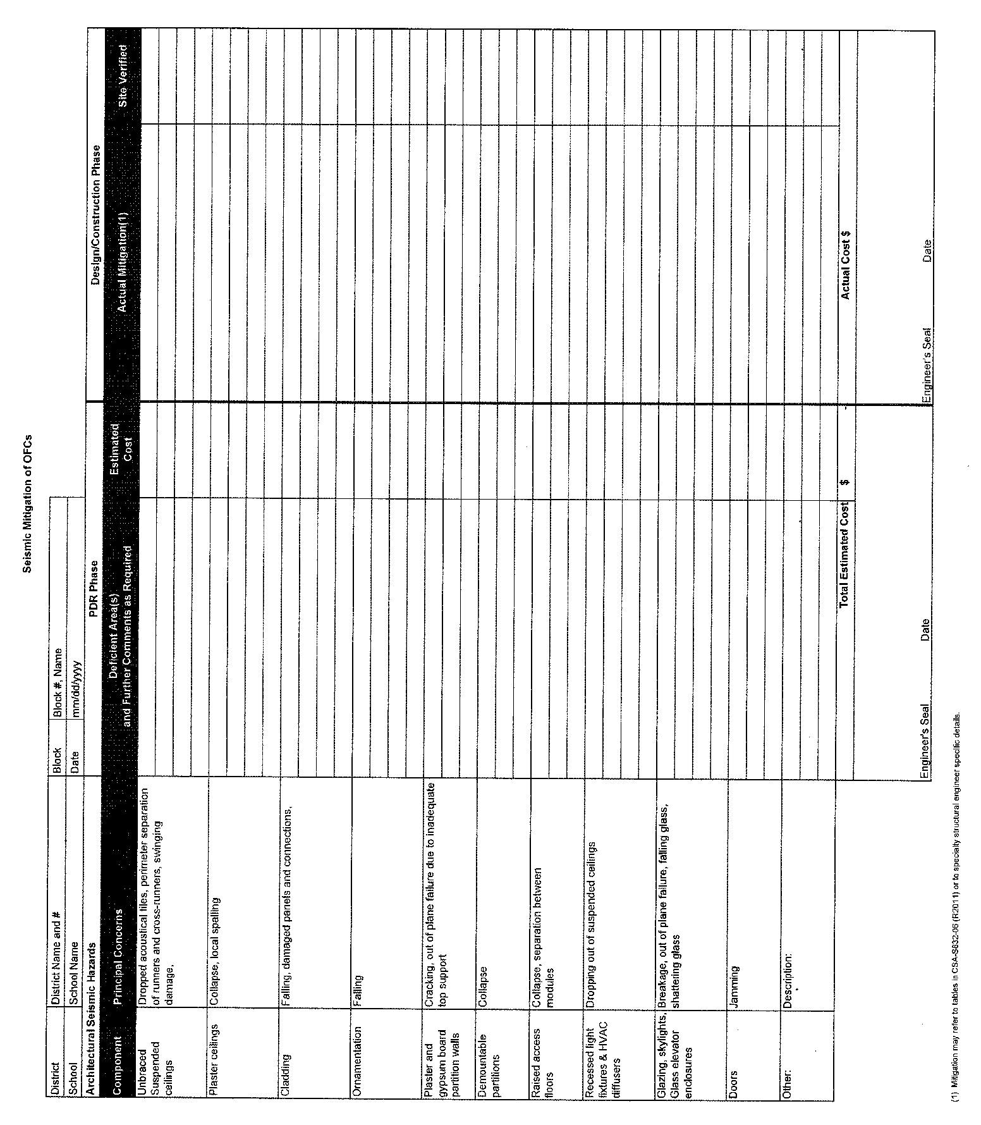
Table G.1: OFCs—Architectural Seismic Hazards

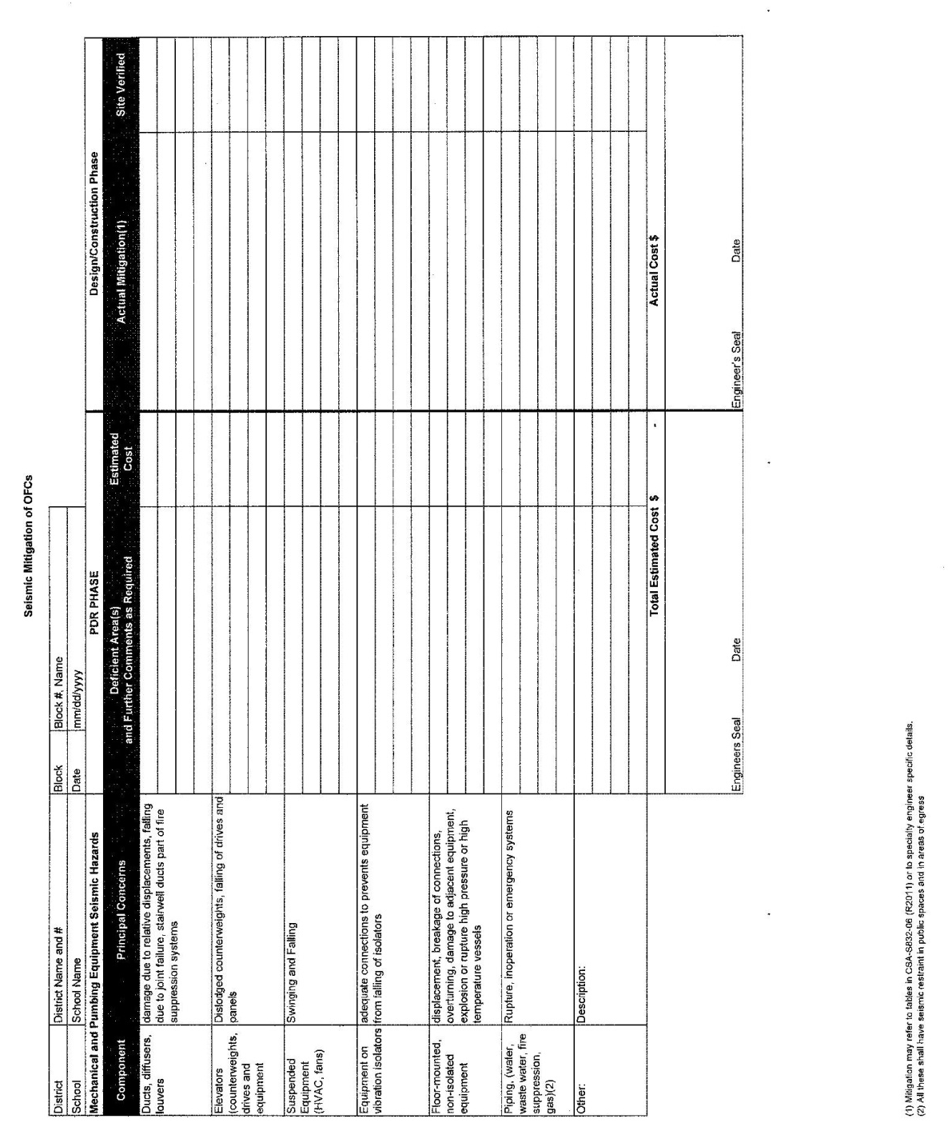
Table G.2: OFCs—Mechanical and Plumbing Equipment Architectural Seismic Hazards

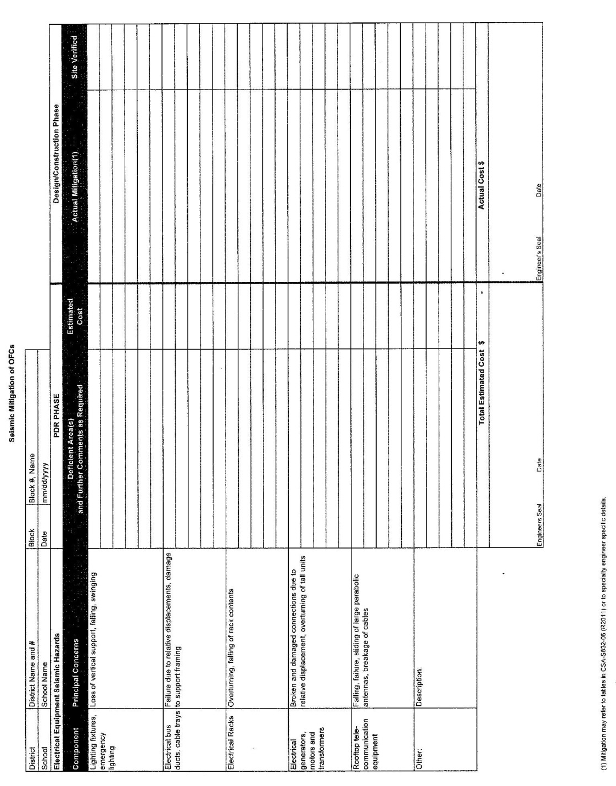
Table G.3: OFCs—Electrical Equipment Seismic Hazards

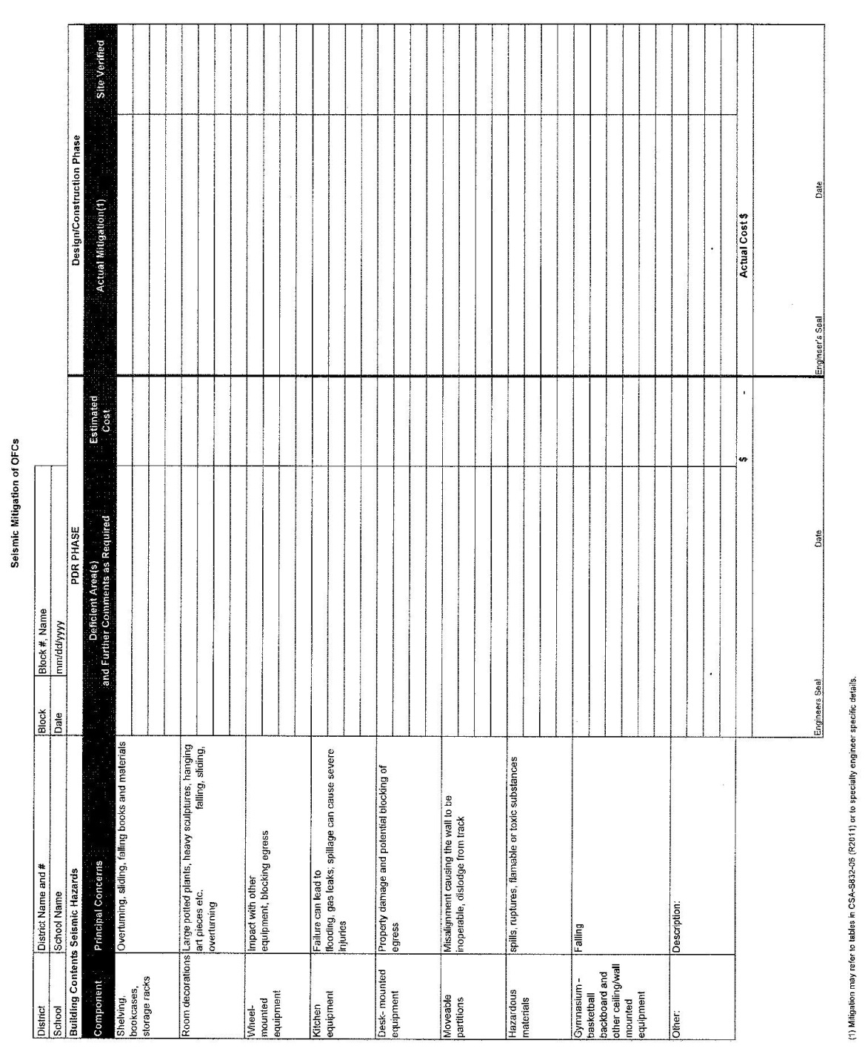
Table G.4: OFCs—Building Contents Seismic Hazards

